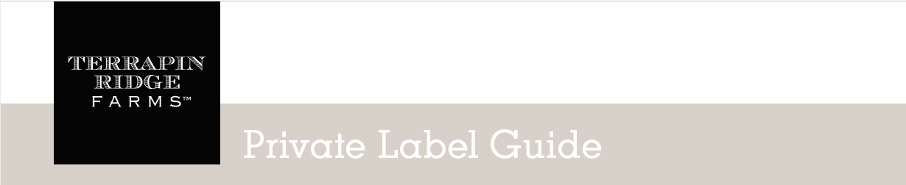

Welcome to Terrapin Ridge Farms Private Label program.
We hope you will find it easy to understand and simple to execute.

Step 1: LABEL CREATION

There are three ways to have your label created:

  - SIMPLE LOGO DROP IN - Send us your logo in a vector format (.ai, eps, pf or .png file type). We will also need your manufactured for information as follows: store name, address, and phone number. We will drop it into our Terrapin approved template with TRF elements and no other alterations will be made. The cost for a Logo Drop In is $20 per SKU.

  - COMPLETE LABEL DESIGN - Perhaps you have an idea of the look you would like to achieve with your label. Or you have products already created with your label and want this product to match your current design. We can create this label for you. You must supply sufficient vector artwork to build elements representative of your brand. We will also need your manufactured for information as follows: store name, address and phone number. The cost for a complete label design is $30 per design hour for the initial design and $20 per SKU for additional labels using this same design.

  - YOU CREATE YOUR LABEL- We will send you the die-line and all the information needed including: nutritional facts, net wt., ingredient statement, etc. You create the label and send us the finished art in a vector format (.ai, eps, pf or .png file type). We print the labels.

Step 2: LABEL ORDERING

- Labeling Cost
  - $250-$1199 order: $0.35/unit labeling fee
  - $1200+ order: $0.25/unit labeling fee
  - Customer supplied labels: $0.10/unit labeling fee.
- Labels will be invoiced as product is ordered.
- We will inventory the labels and let you know when it is time to re-order.

Step 3: PRODUCT ORDER

- Place your order for the product with your label on it.
- We will place your label on a jar and ship your order.
- There is a one week lead time for private label orders due to the time needed to label each jar.
- PLEASE NOTE: to participate in the private label program the sales expectation is that a customer will move through 200 units of each item in 18 months. We may need to charge a fee of $50 per SKU after 18 months if items do not move at this rate.

Here are examples of labels.

